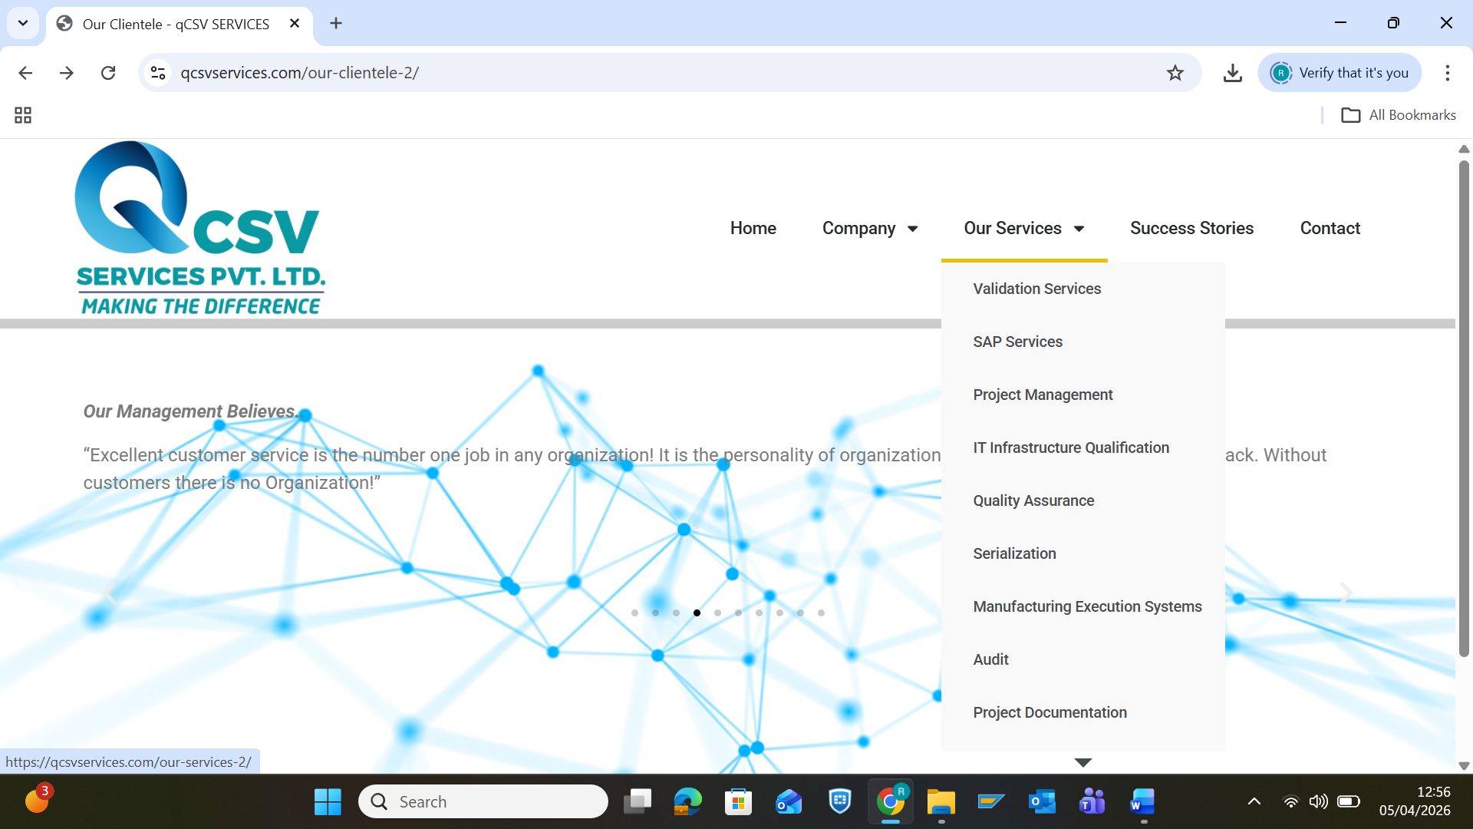
SAP Services
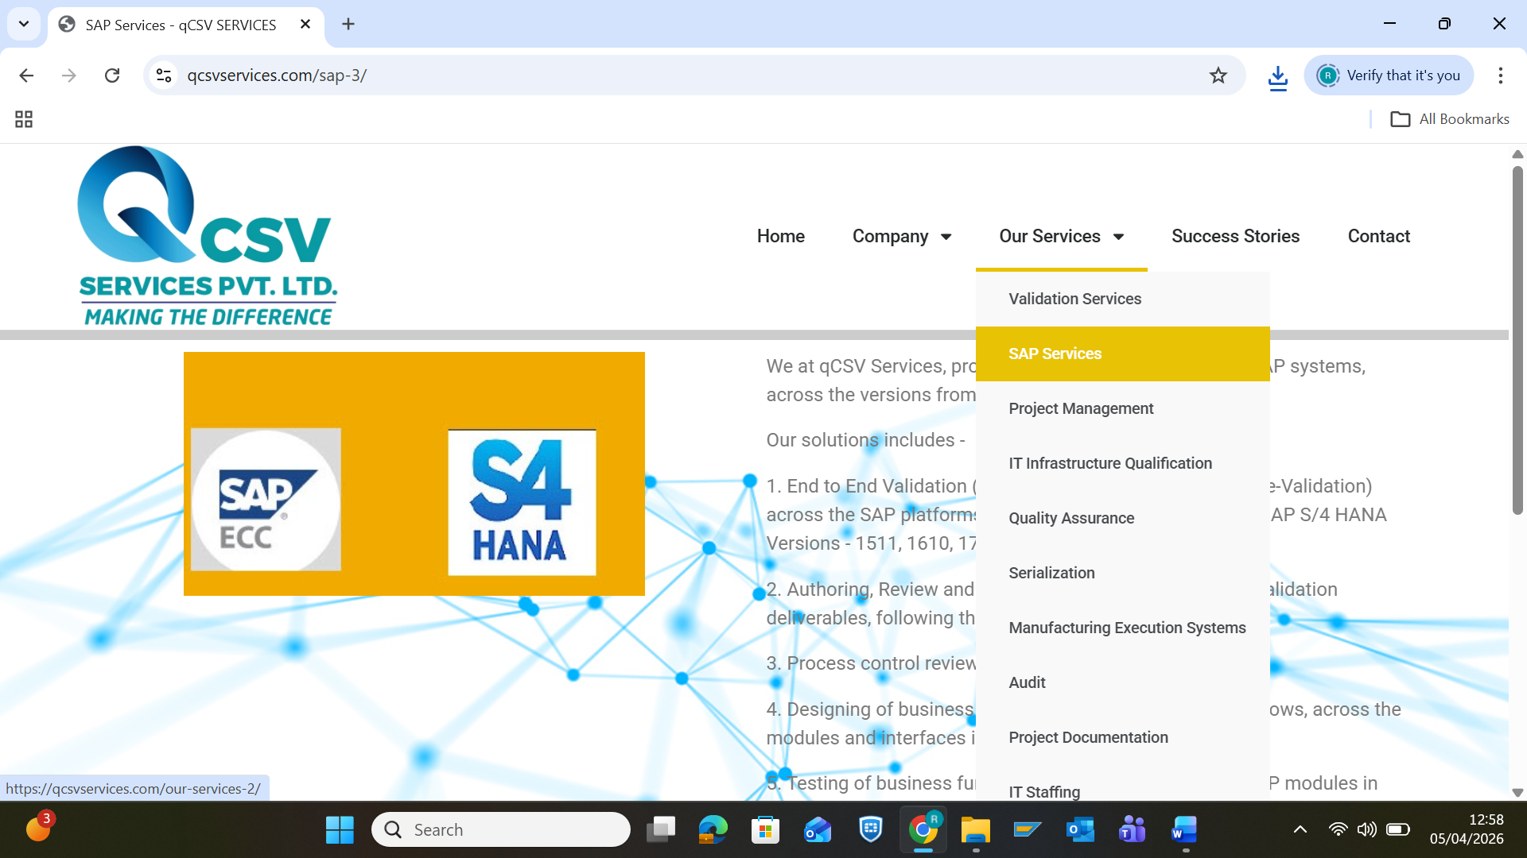
We at qCSV Services, provides an end to end solution for SAP systems, across the versions from SAP ECC to SAP S/4 HANA.
Our solutions includes -
1. End to End Validation (i.e. Prospective, Retrospective & Re-Validation) across the SAP platforms, starting from SAP ECC 6.0, and SAP S/4 HANA Versions - 1511, 1610, 1709, 1809, 1909 and 2020
2. Authoring, Review and Approval of end to end project & validation deliverables, following the industry best practices
3. Process control reviews and assessments
4. Designing of business process and associated process flows, across the modules and interfaces involved
5. Testing of business functions & processes across the SAP modules in different phases - Development & Quality, as part of System integration testing (SIT), Operation qualification (OQ) & Performance qualification (PQ) / User acceptance testing (UAT)
6. IT Infrastructure qualification
7. Data migration qualification & verification of migrated data
8. Preparation of SOPs, Work instructions and End user manuals, for business functions across the SAP modules
9. Project Co-ordination and Project Management
10. Technical upgrade support in defining the strategy & generation of associated deliverables
11. Training to project team (i.e. Internal & External) on topics like - SAP business processes, CSV & its lifecycle approach, GAMP 5, Project templates, Regulations - US FDA 21 CFR Part 11 & EU Annex 11 & many more.

Project Management
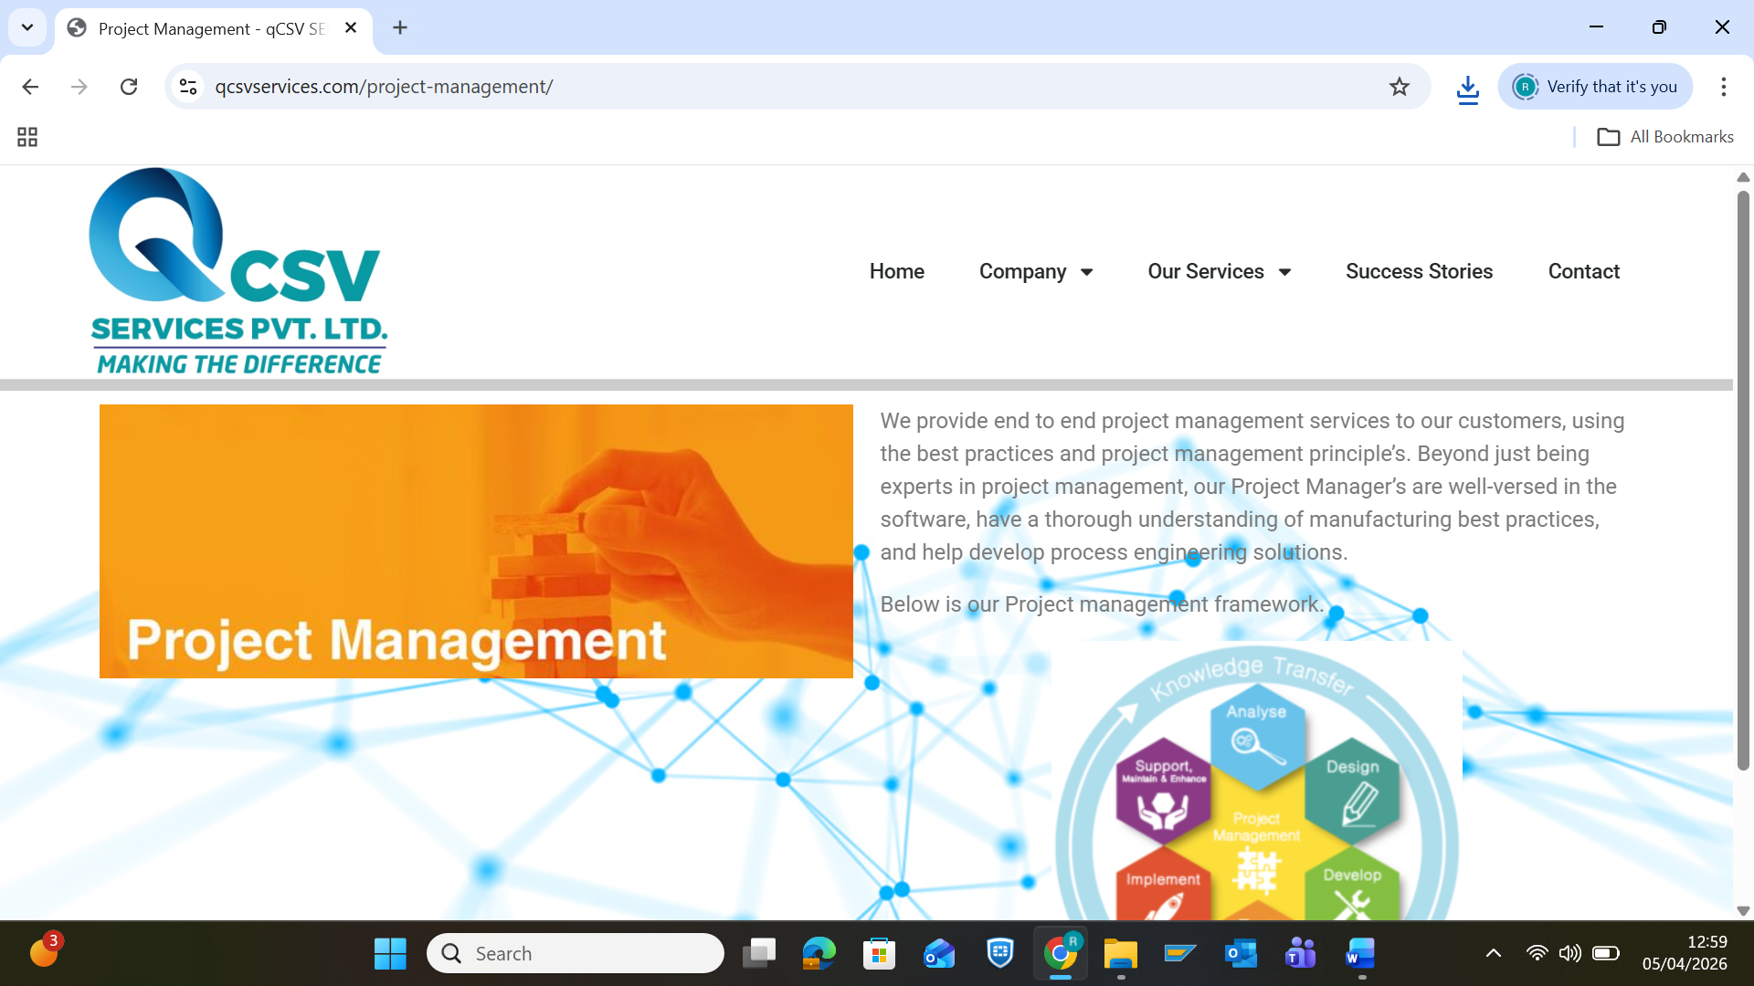
We provide end to end project management services to our customers, using the best practices and project management principle’s. Beyond just being experts in project management, our Project Manager’s are well-versed in the software, have a thorough understanding of manufacturing best practices, and help develop process engineering solutions.
Below is our Project management framework.
Insert image

IT Infrastructure Qualification
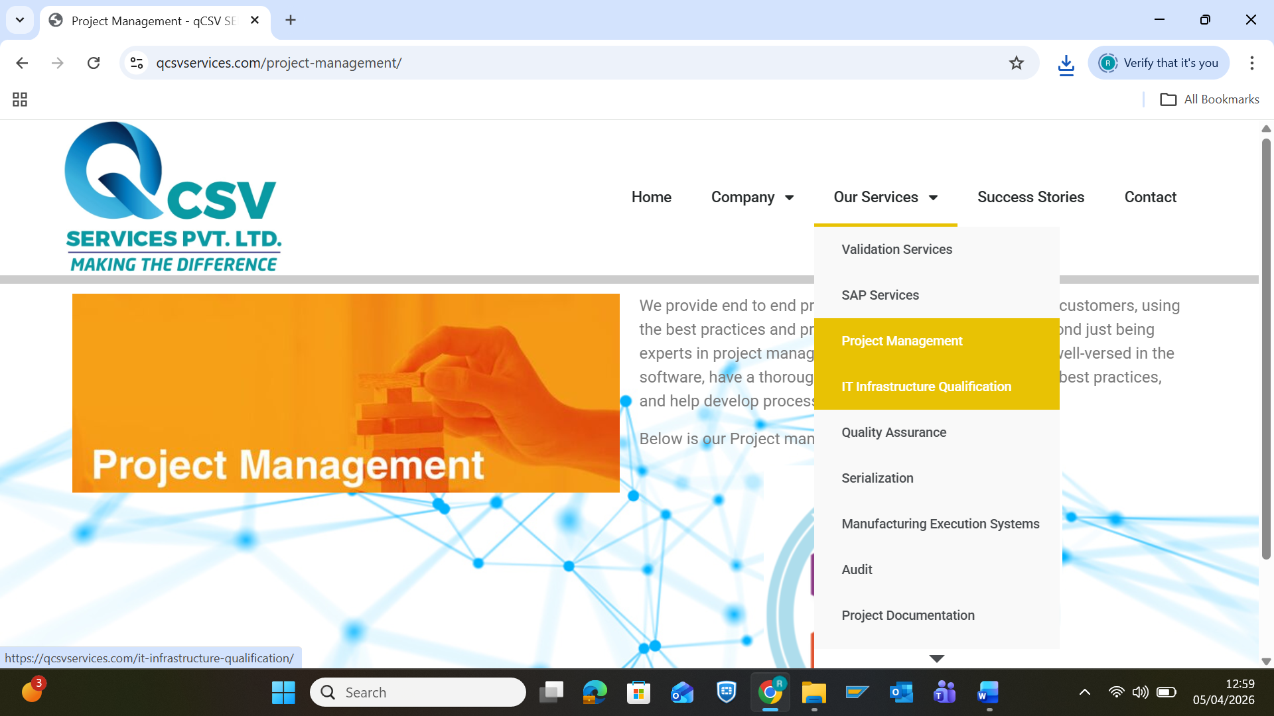
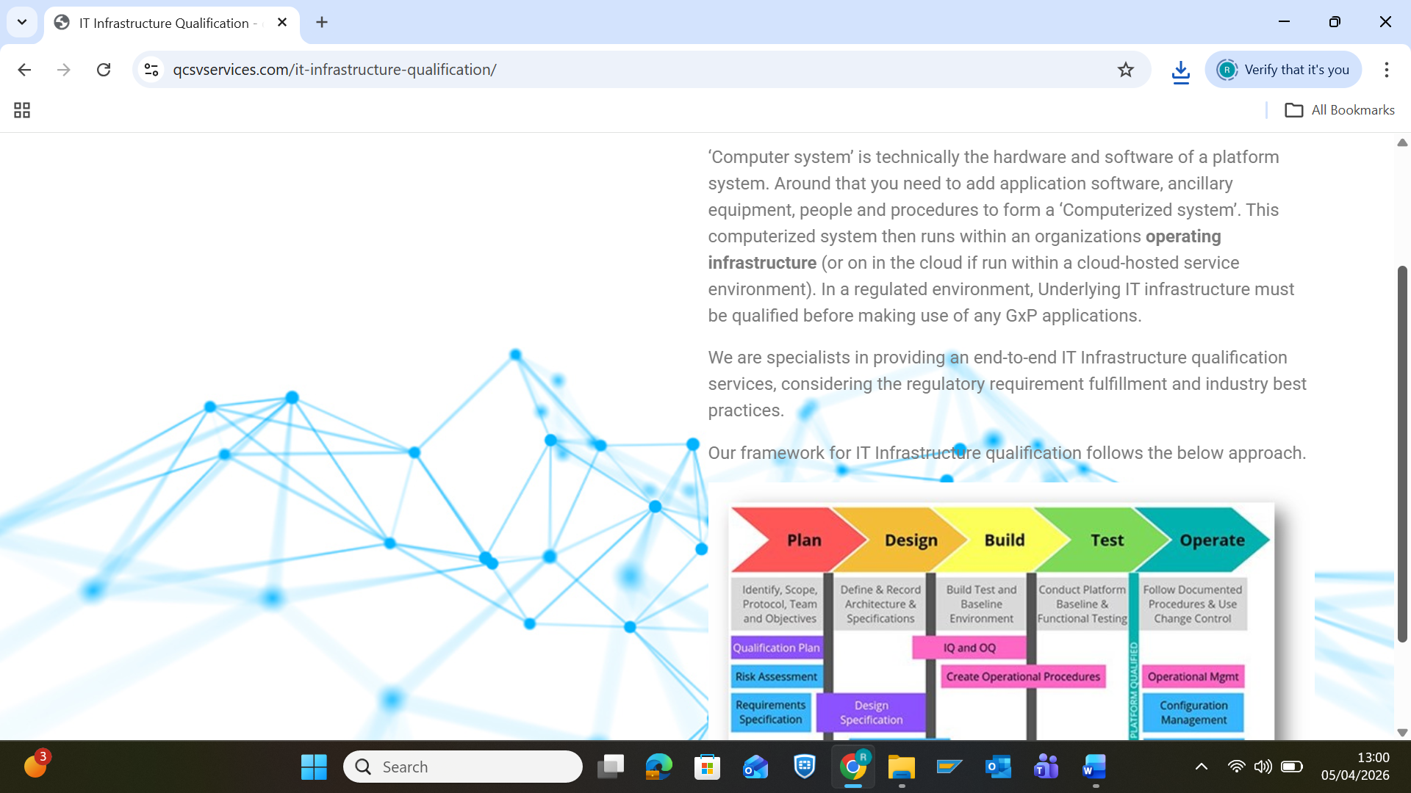
‘Computer system’ is technically the hardware and software of a platform system. Around that you need to add application software, ancillary equipment, people and procedures to form a ‘Computerized system’. This computerized system then runs within an organizations operating infrastructure (or on in the cloud if run within a cloud-hosted service environment). In a regulated environment, Underlying IT infrastructure must be qualified before making use of any GxP applications.
We are specialists in providing an end-to-end IT Infrastructure qualification services, considering the regulatory requirement fulfillment and industry best practices.
Our framework for IT Infrastructure qualification follows the below approach.

Quality Assurance
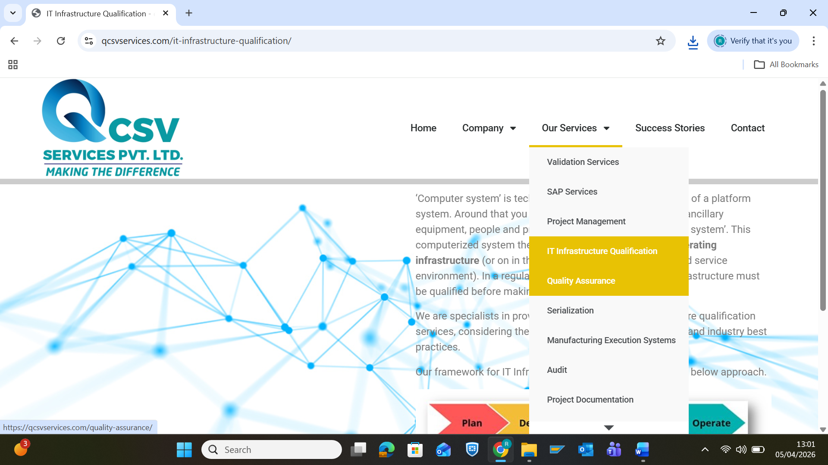
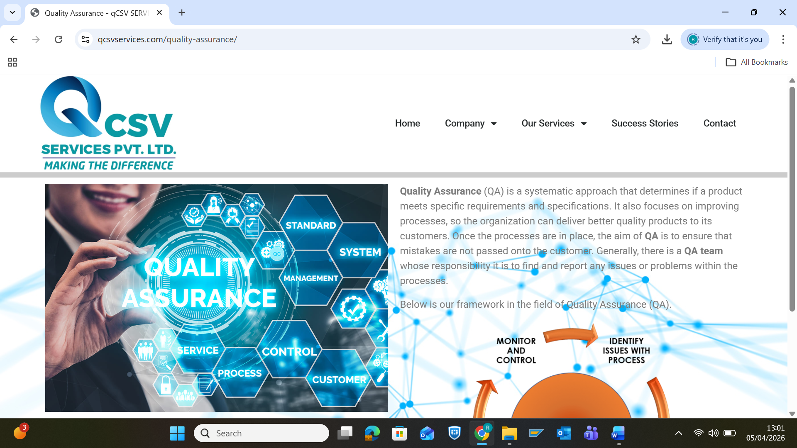
Quality Assurance (QA) is a systematic approach that determines if a product meets specific requirements and specifications. It also focuses on improving processes, so the organization can deliver better quality products to its customers. Once the processes are in place, the aim of QA is to ensure that mistakes are not passed onto the customer. Generally, there is a QA team whose responsibility it is to find and report any issues or problems within the processes.
Below is our framework in the field of Quality Assurance (QA).
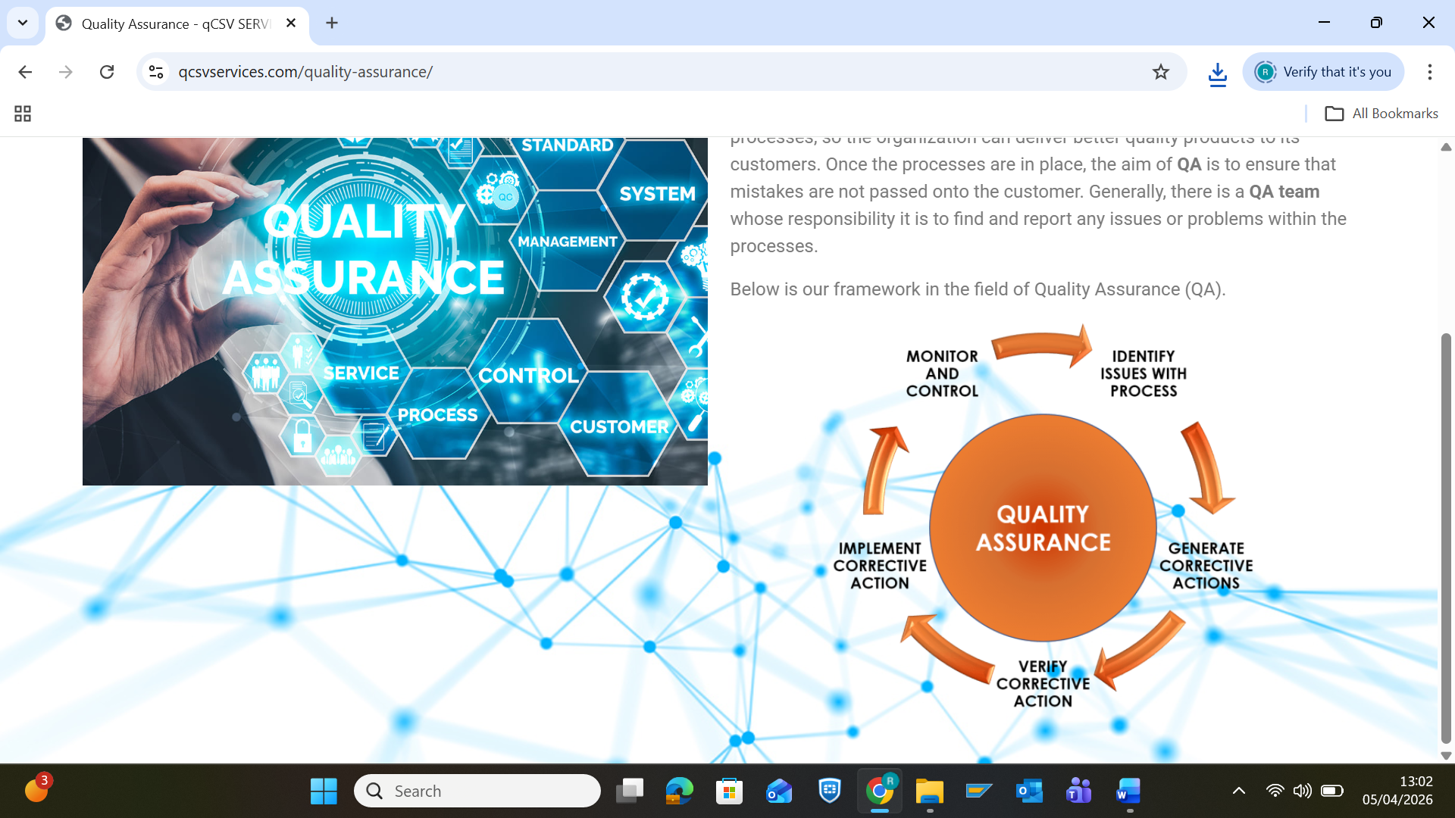

Serialization
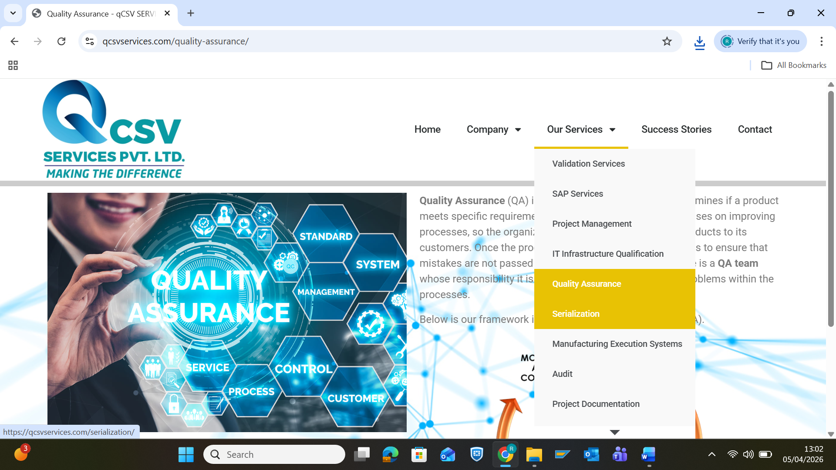
Manufacturing Execution System (MES)
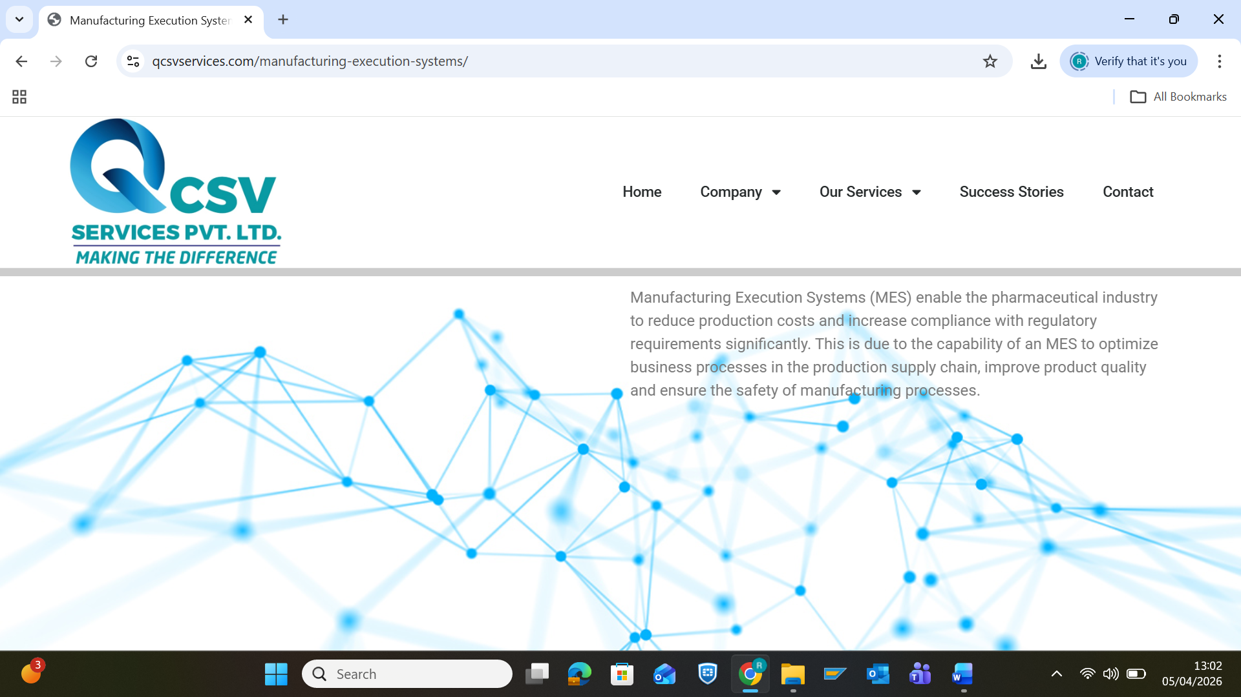
Manufacturing Execution Systems (MES) enable the pharmaceutical industry to reduce production costs and increase compliance with regulatory requirements significantly. This is due to the capability of an MES to optimize business processes in the production supply chain, improve product quality and ensure the safety of manufacturing processes.
Audit
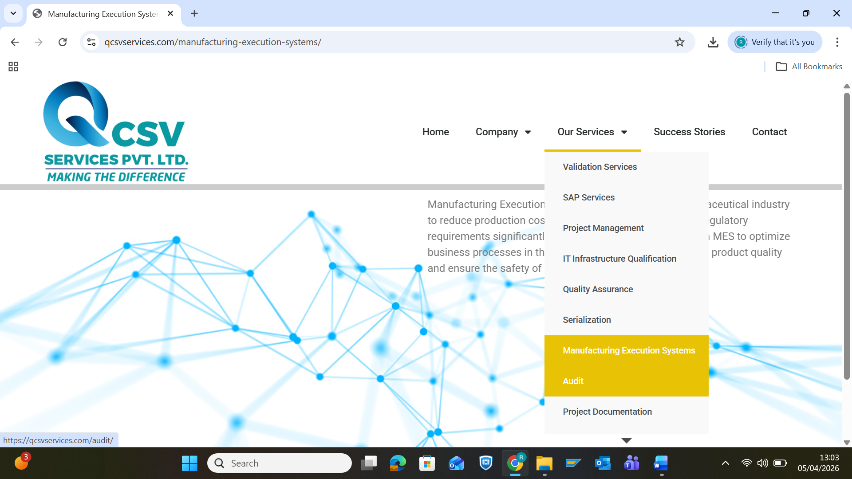
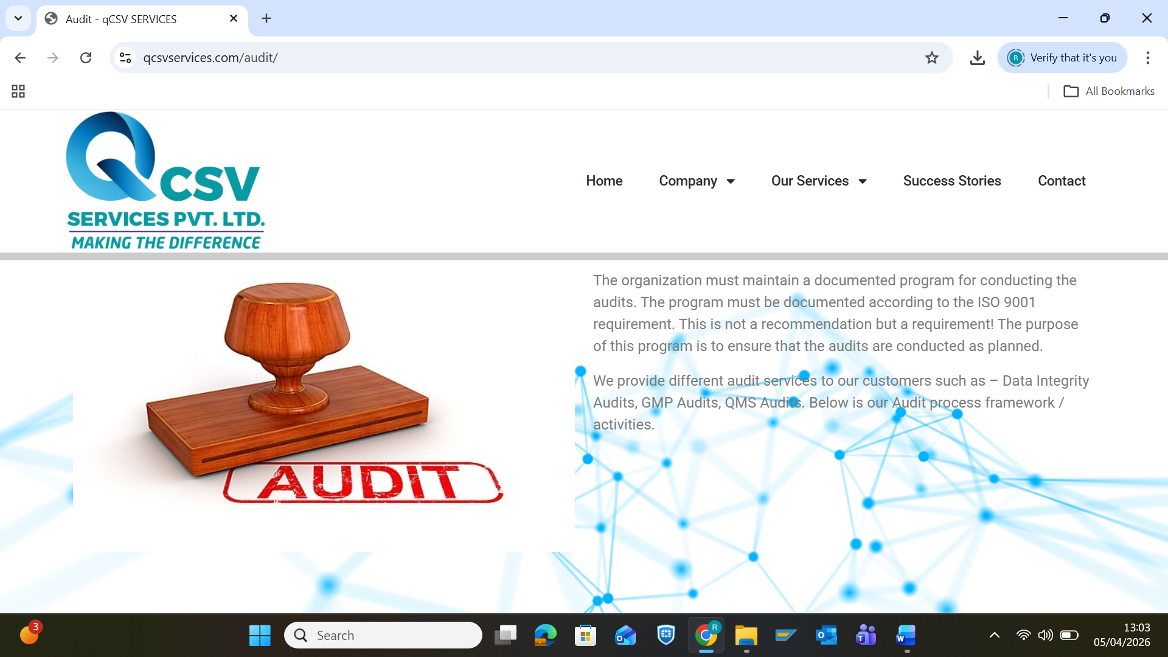
The organization must maintain a documented program for conducting the audits. The program must be documented according to the ISO 9001 requirement. This is not a recommendation but a requirement! The purpose of this program is to ensure that the audits are conducted as planned.
We provide different audit services to our customers such as – Data Integrity Audits, GMP Audits, QMS Audits. Below is our Audit process framework / activities.

Project Documentation
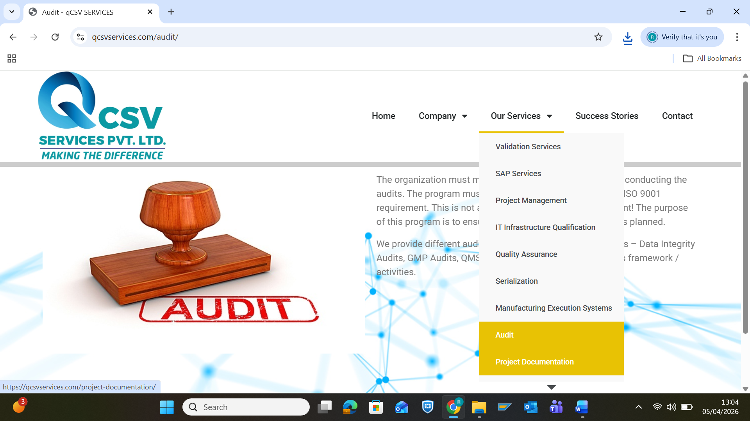
IT Documentation is the structured recording of information pertaining to an IT ecosystem. We are specialist in project documentations across the Software development lifecycle phases, which includes but not limited to – Lifecycle deliverables, SOPs, Work Instructions, End user manuals and many more.
Our framework for SDLC phases and associated phase wise documentations are:
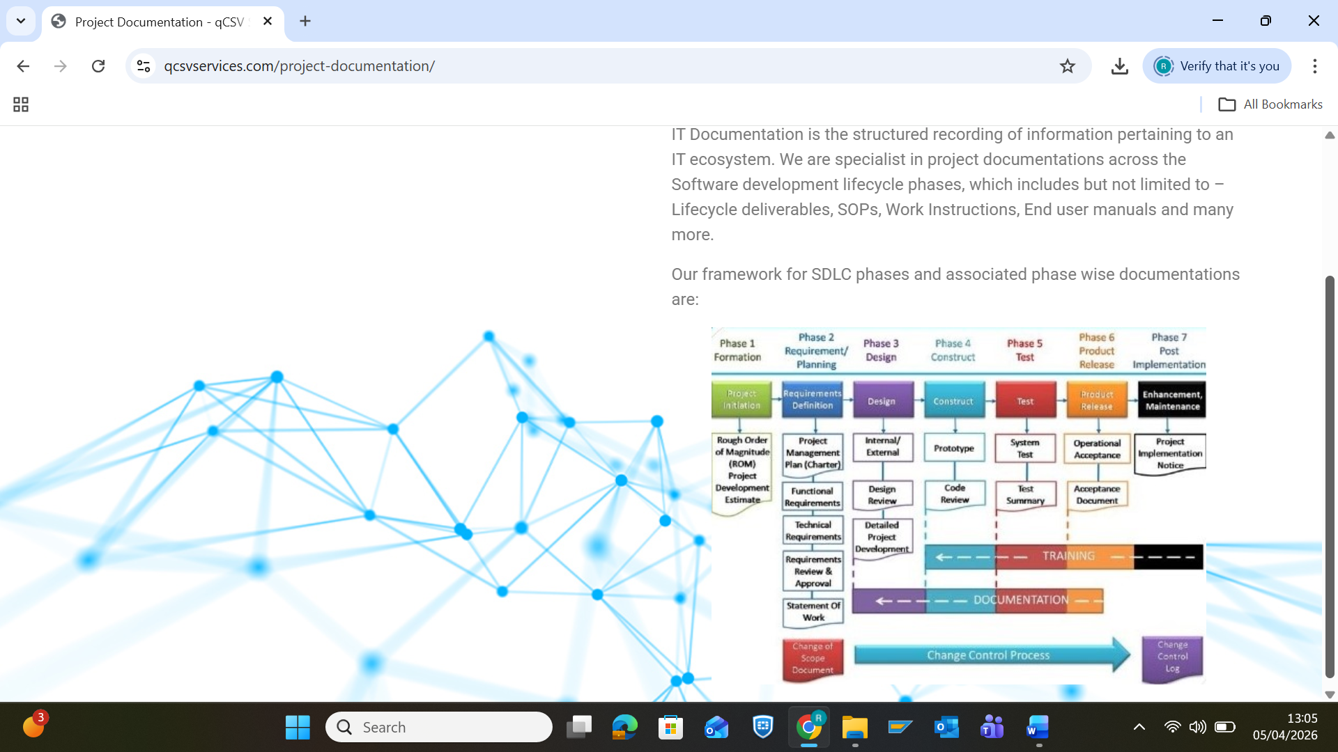
IT Staffing
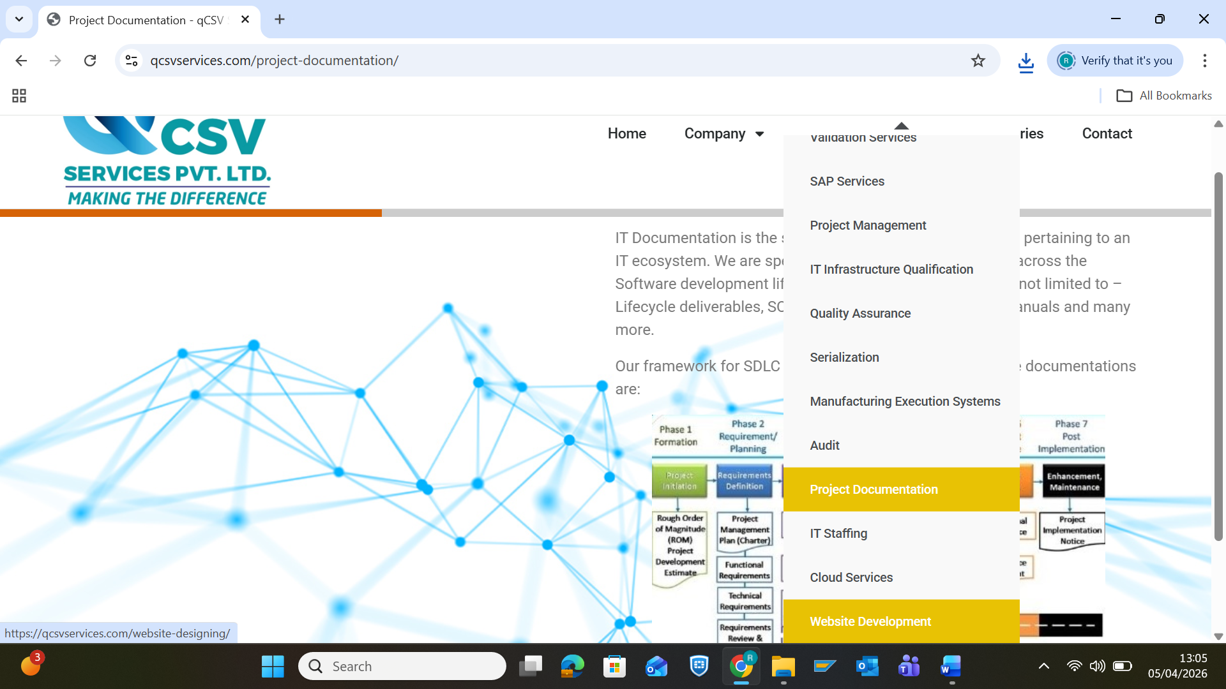
We provides IT staffing services and has been immensely successful in creating a network of highly adept intelligent workforce that can help an organization achieve their mission-critical projects and goals.
Our staffing services benefits the customer in term of:
- Highly skilled staffs
- Less expensive
- Accountability
- Easy to scale up or down

Cloud Services
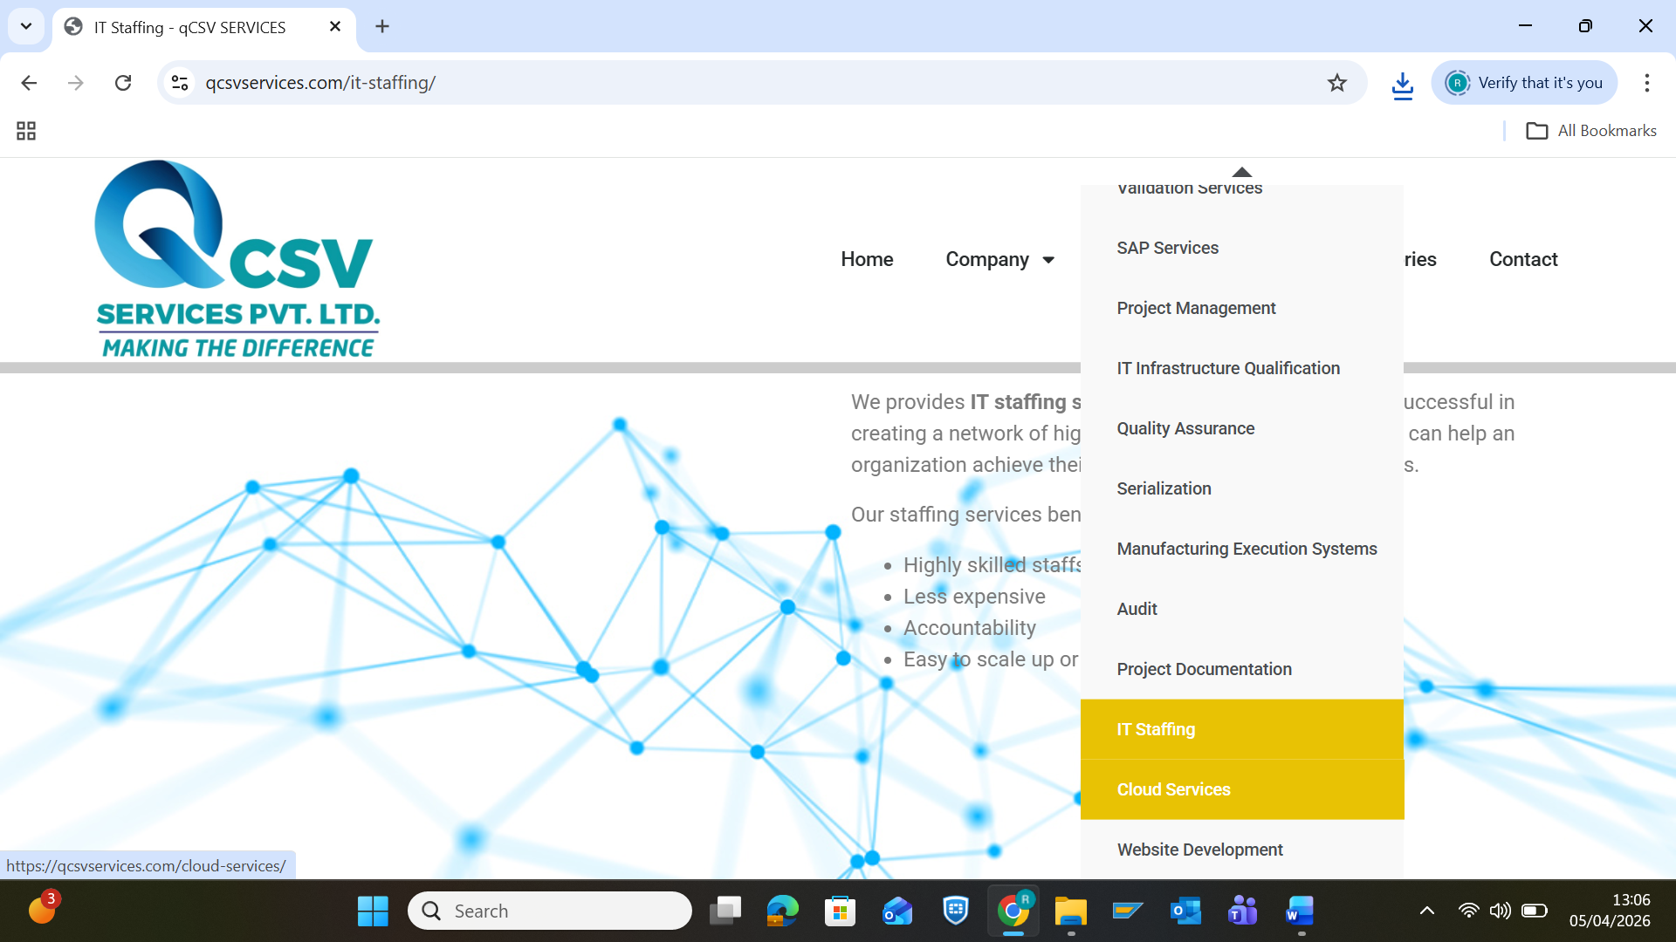
qCSV Services provides a complete range of cloud services, such as – Cloud validation, Cloud computing solutions and likewise.
Website Development
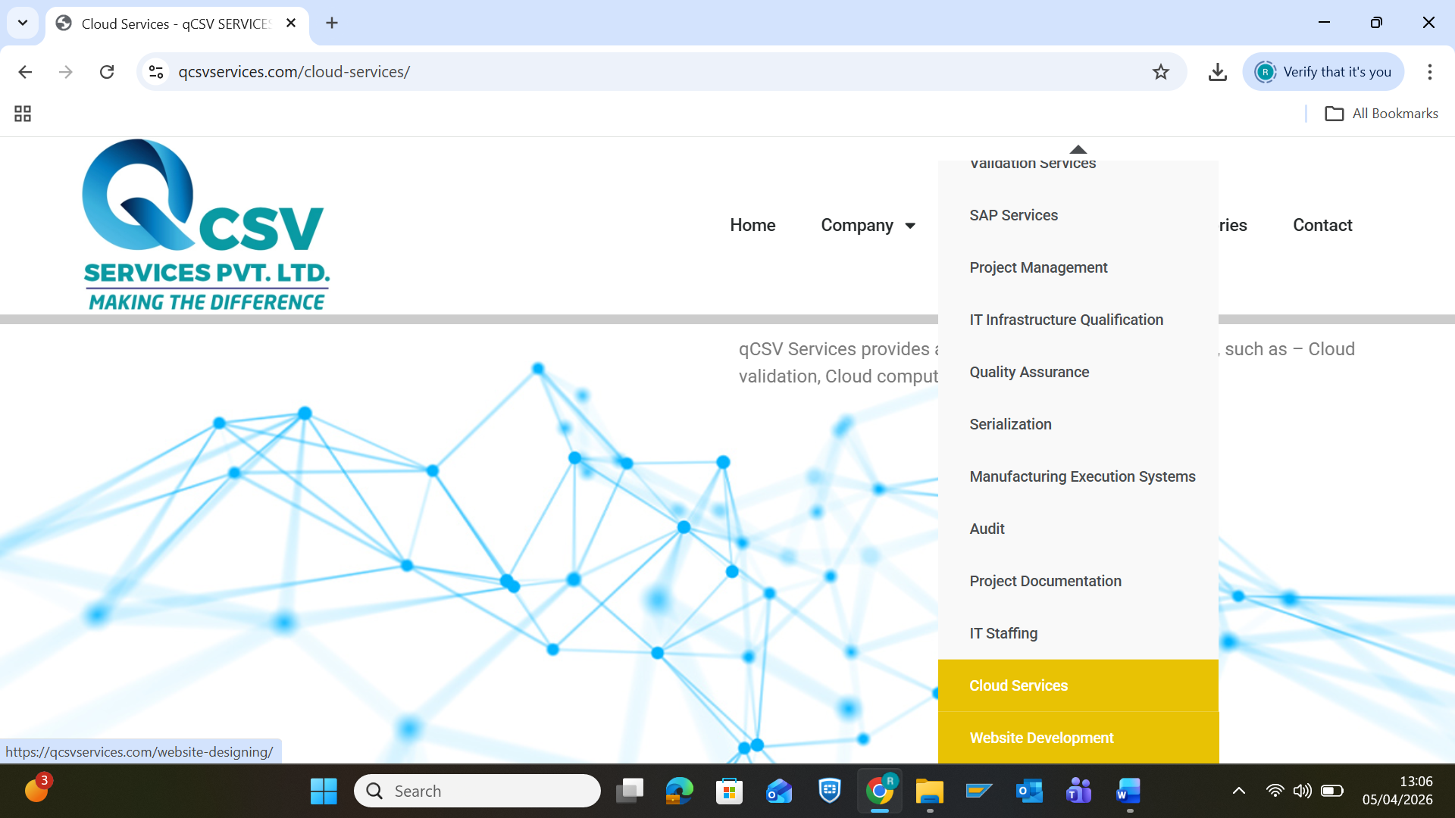
We make beautiful websites, creative designs, customized as per your requirement. qCSV Services, is known for its creative and unique designing skills. We aim to convert outstanding ideas into artistic websites.

